|  |  |
| --- | --- |
|  | This section provides a number of viewpoints of the target API Reference Architecture from the conceptual domains to the realization of a platform and the capabilities. These viewpoints are used to help guide solution architects in the determination of the domain, platform and capabilities represented within their solution architectures.  **Business Architecture**  **Business Domains**  Business Domain viewpoints:  Enterprise Domain Sub-domains (as an example of sub-domains):  **Domain Context**  **Platform, Domains and Bounded Context**  What is a Platform?  Platform vs Portfolios  Benefits of a Platform approach  Platform vs Traditional Monolithic, Siloed Approach  Platform Characteristics  Platform examples  Platforms and Applications  Platform Capabilities  **Value Stream and Value Chains: APIs’ roles**  Value Stream  Value Chain  Commerce  Commerce as a Value Stream  APIs in the Commerce Value Stream |

# Business Architecture

Business architecture is the bridge between the enterprise business model and the enterprise strategy on one side, and the business functionality of the corporate business or organization on the other side.

From TOGAF:

*A knowledge of the Business Architecture is a prerequisite for architecture work in any other domain (Data, Applications, Technology), and is therefore the first architecture activity that needs to be undertaken, if not catered for already in other organizational processes (enterprise planning, strategic business planning, business process re-engineering, etc.).*

*In practical terms, the Business Architecture is also often necessary as a means of demonstrating the business value of subsequent Technical Architecture work to key stakeholders, and the return on investment to those stakeholders from supporting and participating in the subsequent work.*

*The extent of the work in Phase B will depend to a large extent on the enterprise environment. In some cases, key elements of the Business Architecture may be done in other activities; for example, the enterprise mission, vision, strategy, and goals may be documented as part of some wider business strategy or enterprise planning activity that has its own lifecycle within the enterprise.*

*In such cases, there may be a need to verify and update the currently documented business strategy and plans, and/or to bridge between high-level business drivers, business strategy, and goals on the one hand, and the specific business requirements that are relevant to this architecture development effort. (The business strategy typically defines what to achieve - the goals and drivers, and the metrics for success - but not how to get there. That is the role of Business Architecture.)*

*In other cases, little or no Business Architecture work may have been done to date. In such cases, there will be a need for the architecture team to research, verify, and gain buy-in to the key business objectives and processes that the architecture is to support. This may be done as a free-standing exercise, either preceding architecture development, or as part of Phase A.*

# 

# Business Domains

The domain viewpoint provides the conceptual viewpoint of the domain boundaries and their context. Following domain driven design will identify the systems, process, data and people within a bounded context. The bounded context is a logical grouping of business processes and relates to one domain or subdomain within the frameworks. Each domain has its own ubiquitous language unique to the domain. Domains express their business capability through enterprise defined logical services enabling easy integration between domains.

## Business Domain viewpoints:

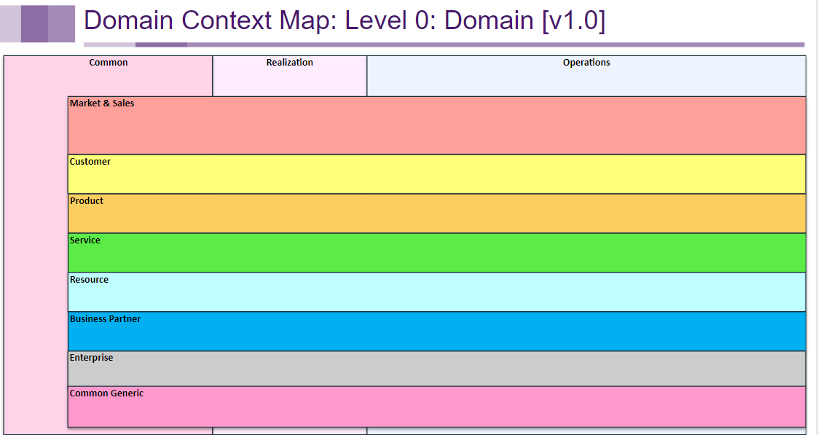

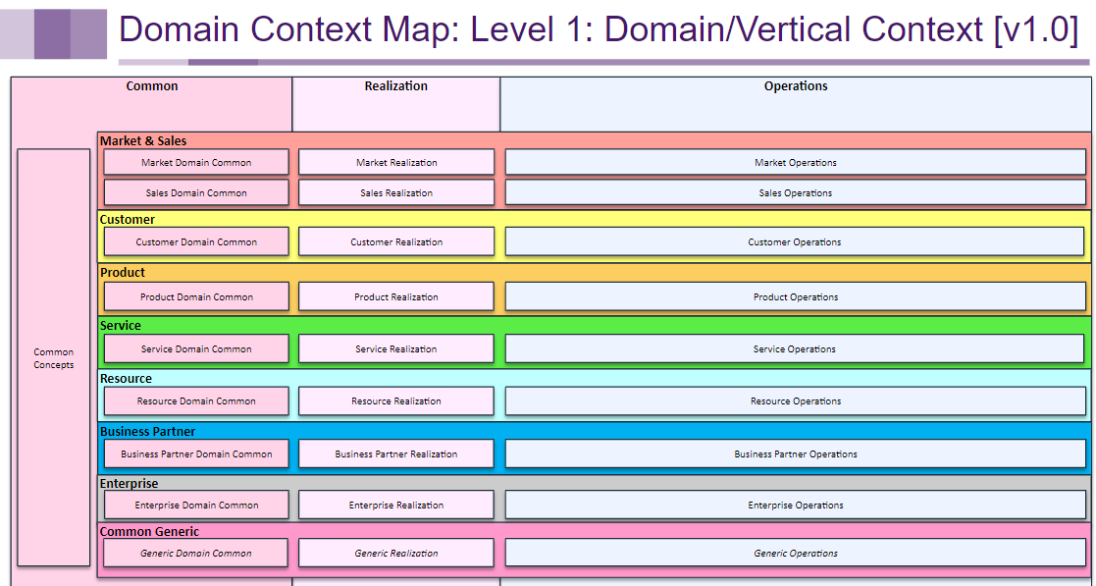

## Enterprise Domain Sub-domains (as an example of sub-domains):

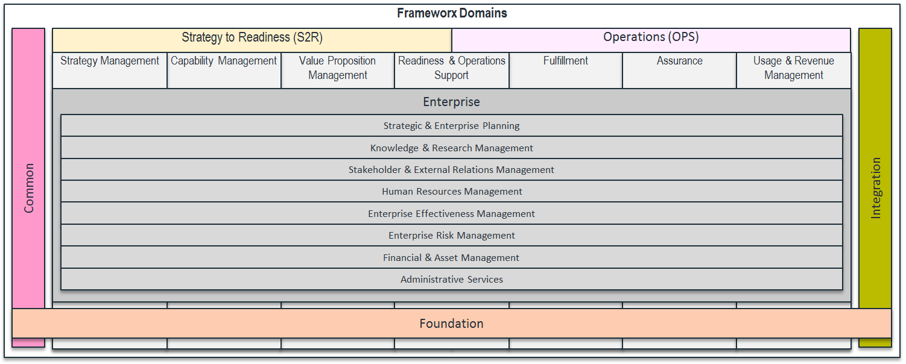

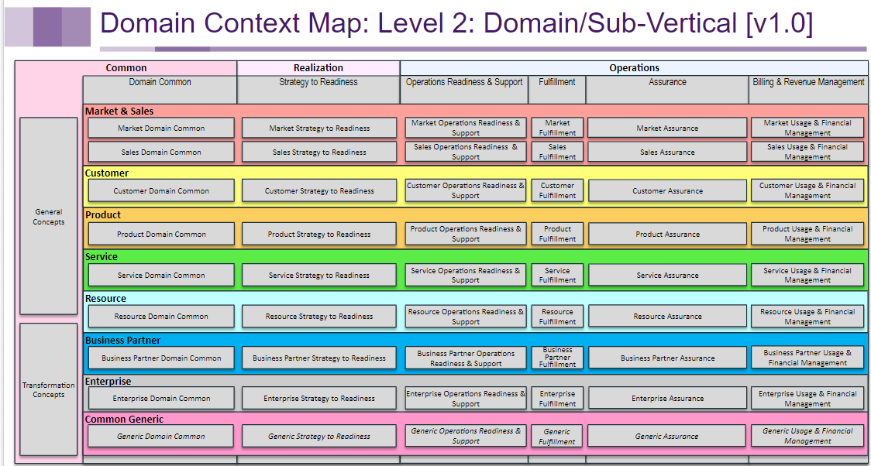

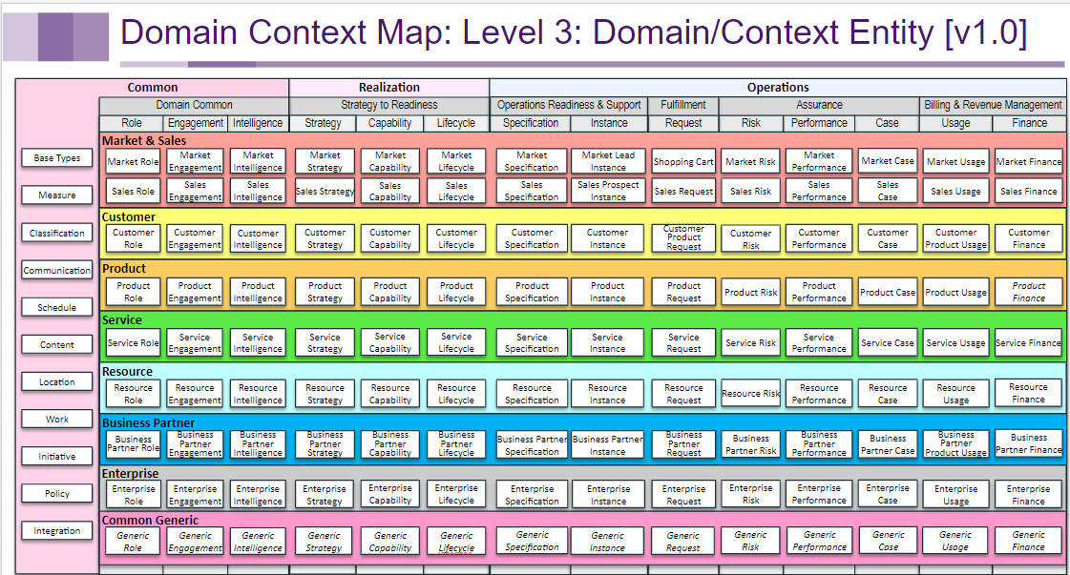

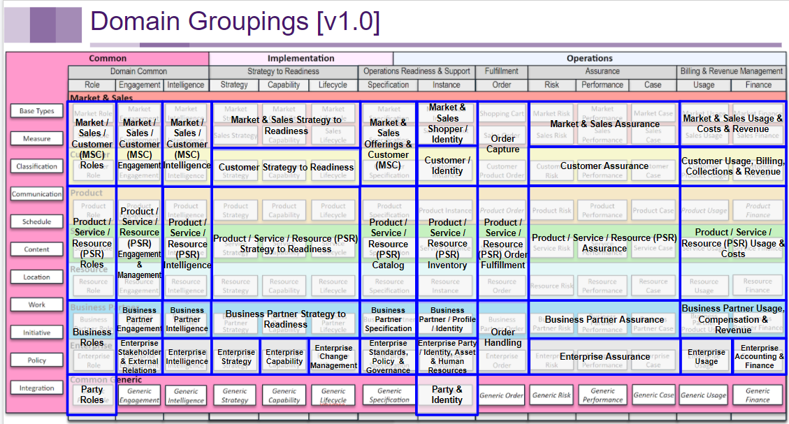

# Domain Context

Please see [TELUS Domain Context](https://docs.google.com/document/u/0/d/1yUNdmekHoBKbntIFZzgmP3Qvkj6NyLsxudZOmM1lhgI/edit) document.

# Platform, Domains and Bounded Context

## What is a Platform?

There are many definitions in the industry of a platform. In the context of the API Reference Architecture a platform is:

* A collection of systems, data, processes and people that collectively provide a well-defined block of business functionality exposed via open APIs.
* The physical realization of the logical collection of systems, data, processes and people as determined from the business architecture.
* Bounds all systems, data, processes and people into one context. A platform is self-contained and independent.
* May consist of more than one domain if it determines that the logical domains are better managed together within one physical platform. For example Product and Customer Management domains are closely related and it may be determined these two logical domains are more easily managed in one Product and Customer Management Platform.
* A services-based architecture used to create an interoperable set of services that can be composed to achieve business objectives
* Focused on providing business capabilities and processes

### Platform vs Portfolios

* <http://go/ea/roadmaps> for TELUS Portfolio roadmaps & current list of portfolios
* *wording around the difference between Platforms, and current TELUS Portfolios - gap with true Platforms*

## Benefits of a Platform approach

* Breaks organizational silos
* Moves focus to business outcomes and away from a specific technology or point solution
* Product focus
* Defined by a bounded-context of systems, data, processes and people
* Enables the simplification of architecture within the platform through system decommissioning
* Simplifies the integration between platforms to the capabilities each platform exposes

## Platform vs Traditional Monolithic, Siloed Approach

Contrast the platform approach to the traditional approach where each application provides an integration point to their own application capabilities. In this traditional approach applications with the same context, for example product catalog, would each provide a capability to retrieve product catalog information in the structure (language) of their own application. The traditional approach requires consumers to integrate with each other and understand the language of each application’s integration. This approach more tightly binds consumers to specific applications.

## Platform Characteristics

Many communication service providers (CSP) are adopting platform architectures as part of their digital transformation strategies. Platform architectures typically also take a microservice architecture approach. This approach decomposes large monolithic applications down into smaller, reusable components that can be accessed through open APIs. This approach reduces capital and operational costs, and provides new opportunities for revenue.

* Platforms do not overlap. However, a platform can be constructed by encapsulating other platforms
* Platforms may have dependencies on other platforms
* Platforms expose capabilities to consumers (which may or may not be platforms).
* A platform exposes management capabilities for other entities (possibly platforms) to manage the capabilities that it offers to consumers.
* A platform exposes capabilities to manage the platform itself.

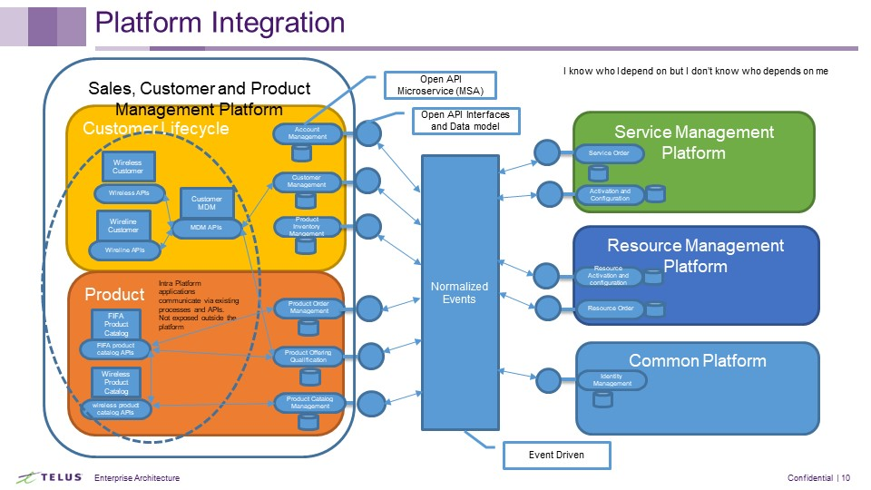

## Platform examples

* Service Management Platform
* Product and Customer Management Platform
* Resource Management Platform

## Platforms and Applications

Bounding applications of the same context into a platform allows the exposure of platform capabilities through a standard port using open APIs. Although there may be many applications within the platform that provide a capability, consumers of the platform’s capabilities only interact with the platform through the Open APIs. The open APIs are the universal language of the enterprise. Using a platform-centric approach simplifies integration through one standard interface (port) for each platform capability. Consumers are not required to understand the language of specific applications within the platform and applications within the platform can be replaced, retired and changed without impacting consumers of the platform.

## Platform Capabilities

Platform capabilities are the realization of business functions that a platform provides. These capabilities are exposed to other platforms within the ecosystem by Open APIs. The purpose of platform capabilities is to enable the design, development, deployment and operation of digital platform businesses.

Each platform capability is a coherent unit of people, processes, systems, policies and information. The capability is exposed through standard APIs to design, develop, compose, deploy and operate services, facilitating the creation and exchange of value among platform participants.

Platform capabilities can be used to realize open, agile, cost-effective, customer-centric platform businesses that are able to outcompete other businesses which do not take full advantage of these capabilities.  Some platform capabilities are essential to any successful, sustainable platform business (e.g., security and privacy capabilities), while other capabilities may not be required depending on the specific platform business strategy and environment.

Platform capabilities may be used to realize non-platform business models (e.g., Pipeline Business Models using Partner Onboarding Capabilities to manage its Supply Chain). Platform capabilities may also be used within Enterprises to improve the outcomes of internal organizational units (e.g., the IT organization uses Virtual Networking Capabilities to accelerate delivery, improve quality, and reduce the cost of IT networking services).

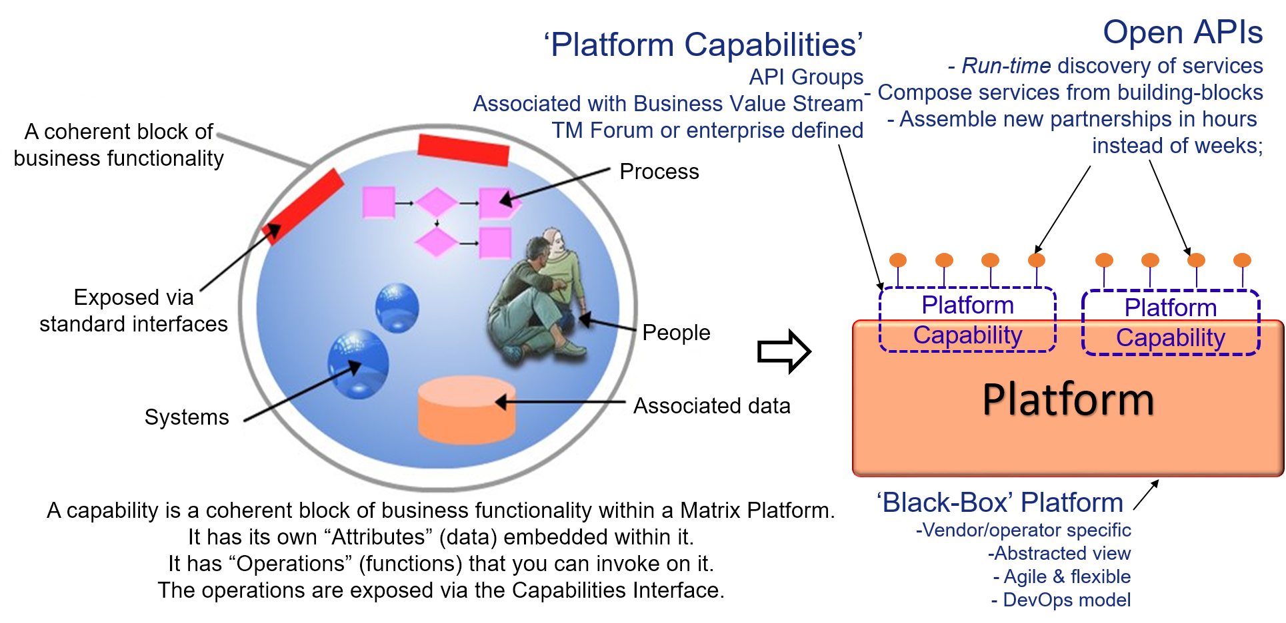

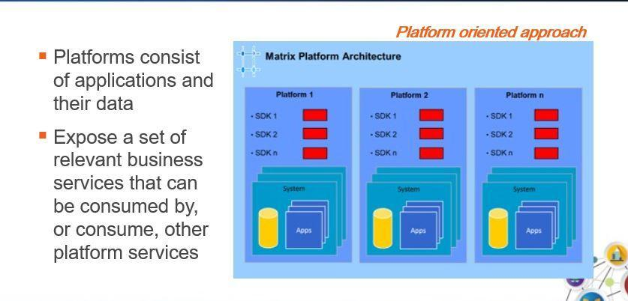

Information exchange is enabled between platforms via APIs.

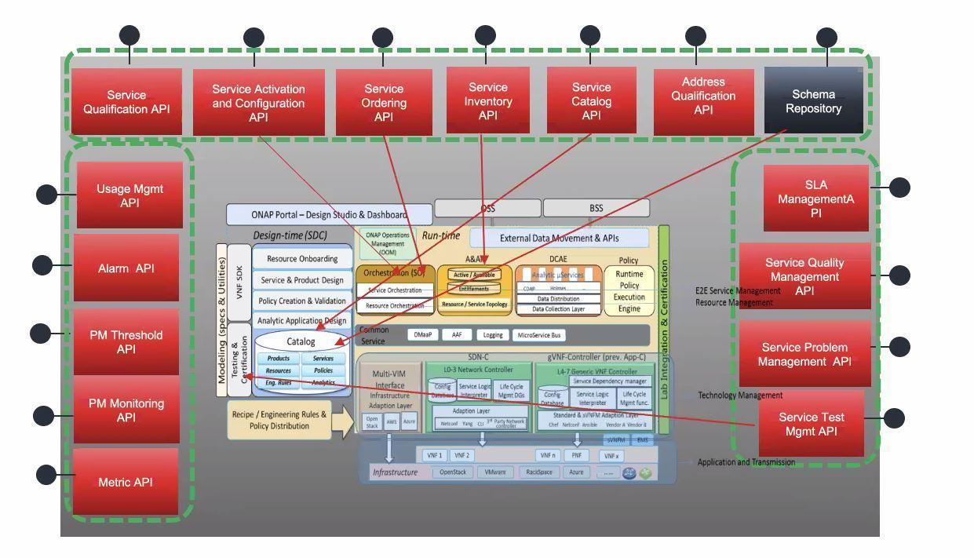

Below is an example of information exchanged between platforms in an E2E fulfillment process:

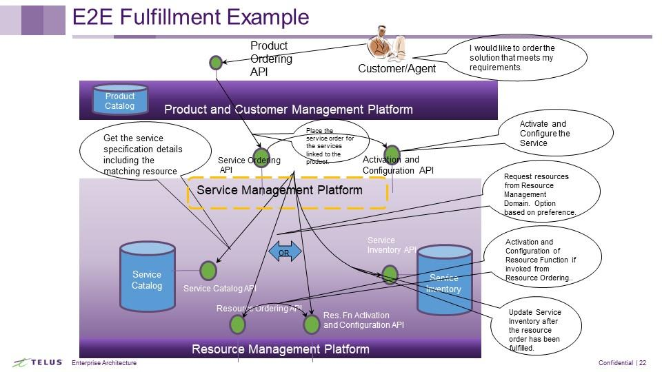

# Value Stream and Value Chains: APIs’ roles

*Insert link to Value chain diagram*

## Value Stream

A Value Stream are artifacts within business architecture that allow a business to specify the value proposition derived by an external (e.g., customer) or internal stakeholder from an organization.

## Value Chain

A value chain is a business model that describes the full range of activities needed to create a product or service. The purpose of a value-chain analysis is to increase production efficiency so that a company can deliver maximum value for the least possible cost.

## Commerce

An interchange of goods or commodities. The transfer of goods or services from one person or entity to another, often in exchange for money.

## Commerce as a Value Stream

Commerce is a value stream which utilizes the capabilities of the enterprise in order to provide goods and services to other parties such as Customers. Commerce itself is not a capability but a collection of all capabilities that enable the enterprise in the exchange of goods and services.

## APIs in the Commerce Value Stream

APIs used to support the commerce value stream are underlined in the following narrative.

As an enterprise as we interact with parties we gather information about their Identity in order to ensure they have the correct User Role and Permissions and also to be able to analyze Party Interactions in order to improve the parties experience. As the enterprise learns the Identity of the party it is important in order to protect the enterprise and the enterprise’s managed parties. Authorization and Fraud Management are two capabilities critical to the protection of the enterprise and the data in which it is a custodian.

Throughout the commerce value stream the enterprise requires the ability to perform Party Management and understand the Party Roles in order to interact with the Party in the most desirable manner and fulfill its obligation to each Party. Party Management is a critical capability for the enterprise in all value streams.

As an enterprise we must have the capability to show potential customers what goods and services we have to sell. These goods and services are managed in a Product Catalogue and are presented to potential customers as a Product Offering.

The potential customer after browsing the Product Catalogue must have the ability to place a specific Product Offering aside while they consider whether to purchase the product or while they continue to browse the Product Catalogue. A potential customer’s Shopping Cart holds the Product Offerings they are considering purchasing. This temporary and transient entity changes as the potential customer learns about available Product Offerings and can be affected by Product Offerings policies through a Product Offering Qualification check. Additional Product Offerings may be added by the enterprise in which the chosen Product Offerings are dependent. The enterprise may also make Recommendations or offer Promotions based on the chosen Product Offerings.

Once the potential customer has made their Product Offering choices, as an enterprise we require the ability to create a Product Order. The Customer Product Order is created from the Product Offerings that were added to the Shopping Cart. In order to understand the cost of the Product Offerings, the enterprise provides the potential customer a Quote. In order to complete the purchase the customer must be able to provide payment and the enterprise must be able to perform Payment Management. As part of the Payment Management, the enterprise can offer the customer a number of Payment Methods. In order for the enterprise to have reasonable assurance the customer will be able to pay for the Product Offerings the enterprise may perform a credit check through its Credit Management capability. In purchasing the Product Offerings the potential customer and enterprise enter into an Agreement and both parties agreed to the terms and conditions of the Customer Service Level Agreement. Once the order is complete the potential customer is a customer of the enterprise and the enterprise holds information about the customer that must be secured through the enterprise’s Customer Management and Account Management capabilities. Notification about the completion of the order is sent to the customer through the enterprise’s Communication Management capability.

The fulfillment of the Customer Product Order requires assistance from other aspects of the enterprise ecosystem. The decomposition of the Product Offerings within the Customer Product Order will result in one or more Service Orders and one or more Resource Orders. A Service Order may require a Service Activation and Configuration and a Resource Order may have a number of capabilities from Resource Activation, Resource Pool Management to reserve a resource and Number Portability in order to check the availability of a number and request a port in or port out.

As part of fulfilling the Customer Product Order, the enterprise may schedule installation or configuration of Product Offerings through its Work Order Management capability and ship purchased items using Shipping Management. The customer and the enterprise can track the shipment using the Shipment Management.

Once the Customer Product Order is fulfilled the enterprise keeps track of what Product Offerings a customer has through the management of the Customer Product Inventory, the Service Inventory and the Resource Inventory.

As the customer uses the Product Offerings, the enterprise tracks the Usage Management and provides the customer a statement of their Usage Consumption. Both these capabilities are managed at the Customer, Product, Service and Resource levels in order to provide the various perspectives required by the enterprise’s Party Roles and Party Management. The enterprise must be able to provide a Customer Bill to the customer in order to receive Payment and provide the customer with the ability to understand their current Balance.

As part of its agreed terms the enterprise ensures the reliability of the services provided by constantly monitoring the Performance based on defined Performance Thresholds and triggers Alarms in order to proactively ensure the customer continues to receive its services. If an issue arises the enterprise will create and manage a Trouble Ticket either initiated by a customer request or through its proactive monitoring of enterprise systems.

In order to maintain its relationship with customers or potential customers the enterprise will notify the customers and potential customers of Promotions and whether they qualify by performing a Promotion Qualification check. The enterprise will also make Recommendations on new Product Offerings or changes to current. When a customer or potential customer wishes to learn about the promotion or recommendation the commerce value stream starts once again.